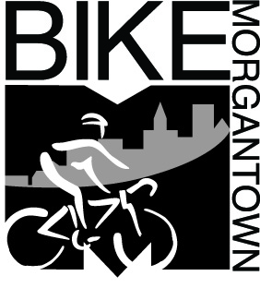

|  |  |  |
| --- | --- | --- |
| **Morgantown Bicycling Plan** | | |
| **Vision** | All Morgantown residents can enjoy bicycling safely and fearlessly anywhere, anytime for any reason. | |
| **Goal** | Bicycle use in Morgantown will continuously increase and bicycle crashes will continuously decrease.  By 2020, 5% of all trips in and through Morgantown will be made by bicycle; 1 in 20 vehicles on the streets will be a bicycle. | |
| **Objectives** | **Education** | Educate bicyclists how to operate their bicycles as vehicles and educate motorists how to treat bicyclists as drivers of vehicles. |
| **Enforcement** | Enforce traffic laws whose violations endanger bicyclists and discourage bicycling. |
| **Engineering** | Remove roadway impediments to bicycle use and build appropriate improvements to make bicycling a safer and more attractive transportation mode than motor vehicle use. |
| **Encouragement** | Provide amenities, rewards and support to citizens for riding their bicycles rather than driving their cars. |
| **Evaluation** | Measure bicycle use and bicycling crashes and use the data to identify improvements. |
| **Equity** | Treat bicyclists as equals to motorists in all city activities. |
| **Initiatives** | Specific prioritized projects to accomplish the objectives. | |