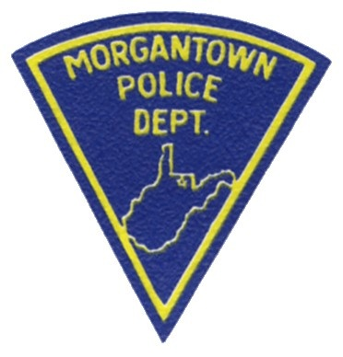
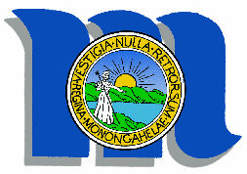
Morgantown Police Department
300 SPRUCE STREET
MORGANTOWN, WEST VIRGINIA 26505
(304) 284-7522
www.morgantownwv.gov

To: Jeff Mikorski, City Manager

From: Ed Preston, Chief of Police

Copies: Bob Roberts, Chief of Police West Virginia University
Town-Gown Advisory Board
Morgantown Traffic Commission
File

Date: November 27, 2013

Subject: PEDESTRIAN / BICYCLIST / DRIVER SAFETY PARTNERSHIP

Pursuant to discussions at the Town-Gown Advisory Board and the Morgantown Traffic Commission the following recommendation is submitted for discussion, modification and possible implementation.

- Pedestrian Safety Initiative
  - WVU PD and Morgantown PD Officers will identify cross-walks and street crossing locations that would be classified as dangerous or most violated based upon factual statistics.
  - Specific dates and times of engagement will be identified for intervention activities.
  - Members of the Morgantown Traffic Commission, Volunteers and University Police Cadets, when available, to distribute informational Fliers/Pamphlets to violators in the identified locations.
  - Law Enforcement Officers will follow up at these locations and take enforcement actions as necessary.
  - Public Safety Announcements regarding pedestrian safety can be produced and aired on the City Web Page, Government Broadcasting Channel with links posted on appropriate web pages and coordinated with WVU PD and University Relations/News for distribution to our campus community.

- Bicycle Safety Initiative
  - Following the end of the educational year for Monongalia County Schools, the Bicycle Unit will be re-constituted for full shift work schedules
  - Morgantown Bicycle Officers will be assigned specifically to the rails to trails and downtown areas as part of their regular patrol duties and will enforce all violations as observed.
  - WVU UP will utilize their bike units during the summer months to increase awareness and educational opportunities.
  - Members of the Morgantown Traffic Commission, Bicycle Board and concerned citizens will be allowed to accompany Officers during designated times and locations and can distribute informational pamphlets

- Driver Safety Campaign
  - Traffic Checkpoints are operated in accordance with State Law and Guidelines established through the Governor’s Highway Safety Campaign.
  - Members of the Morgantown Traffic Commission along with concerned citizens may be allowed to attend scheduled checkpoints and distribute informational literature as appropriate.

