MORGANTOWN BICYCLE PLAN

October 18, 2011

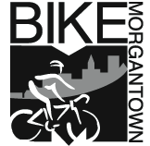

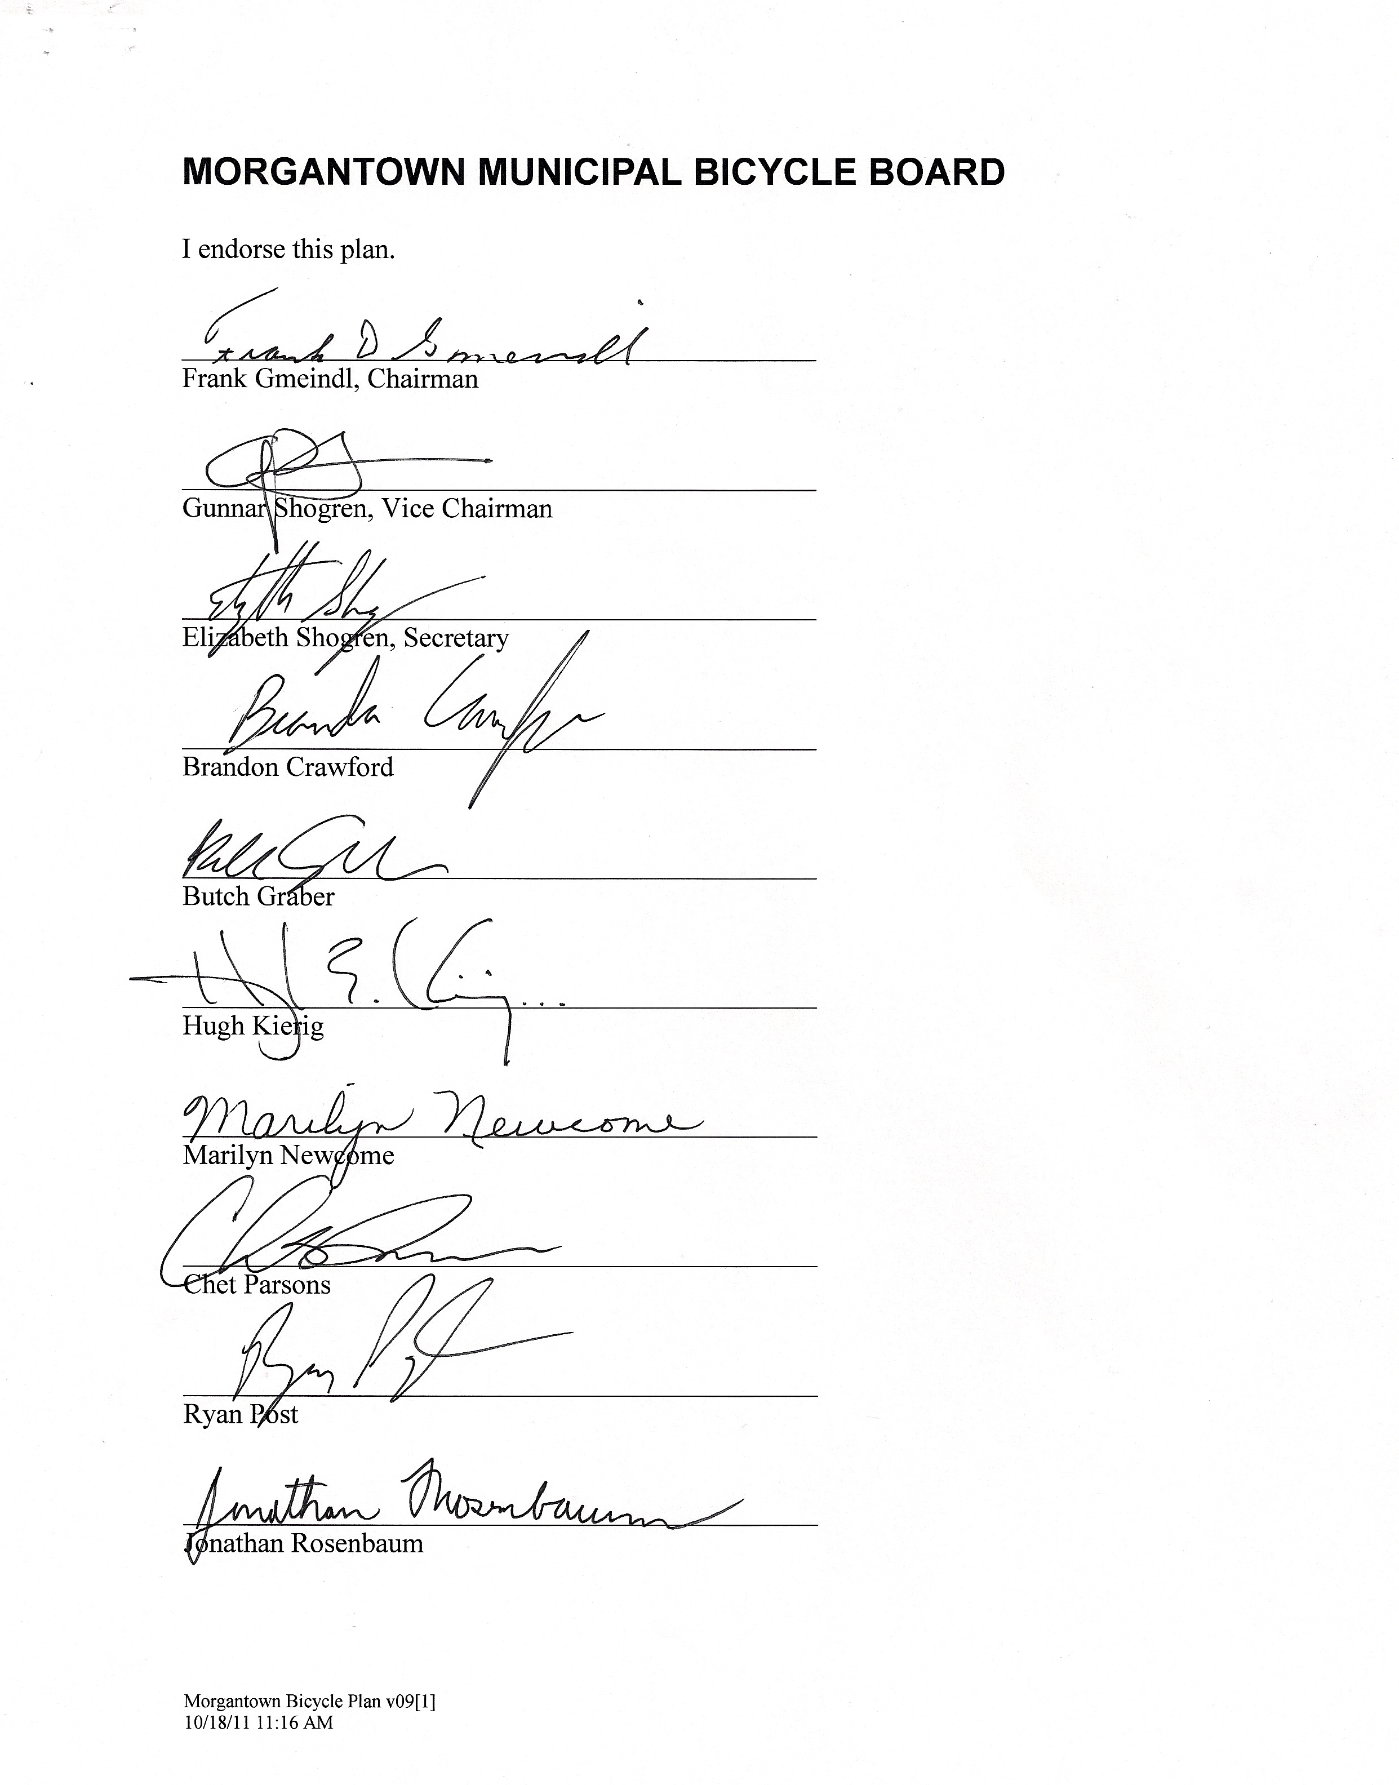

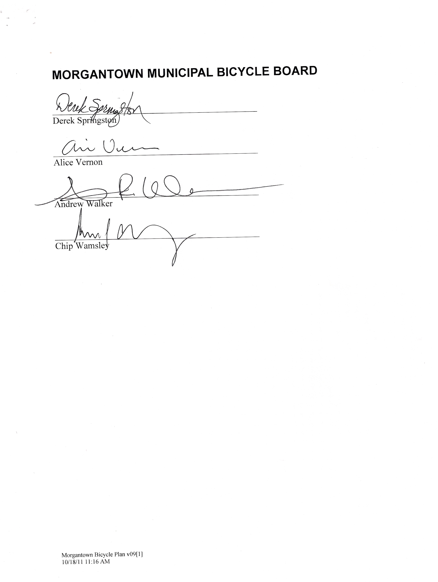

Morgantown Bicycle Plan

Table of Contents
Purpose 1
Plan Scope and Horizon 1
Plan Summary 1
Vision 1
Goal 1
Objectives 1
Plan Development, Implementation and Maintenance 2
Development 2
Implementation 2
Maintenance 2
Why Implement This Plan? 2
Reduced Congestion 2
Greater Transportation Efficiency 3
Better Community Health and Well-being 4
Improved Physical Environment 5
More Prosperous Local Economy 5
Current State: Bicycling in Morgantown 5
Stakeholder Analysis 9
Types of Bicyclists that Must Be Accommodated 10
Type A: Advanced Bicyclists 10
Type B: Basic Bicyclists 11
Type C: Child Bicyclists 11
Public Officials 11
Projects 12
Education 13
Objective: 13
Cyclists fare best when they act and are treated as drivers of vehicles 13
Projects: 13
Enforcement 14
Objective: 14
Almost every collision involves a traffic violation 14
Projects: 15
Engineering 16
Objective: 16
A wide range of needs: 16
Bike Paths 16
Bike lanes 16
Roadways 17
Projects: 18
Encouragement 20
Objective: 20
Projects: 20
Evaluation 21
Objective: 21
Projects: 21
Equity 21
Objective: 21
Bicyclists are people, too 21
Projects: 22
Resources 22
Funding Strategies 22
References 23

Purpose
The purpose of this plan is to make Morgantown a bicycle friendly community.

Plan Scope and Horizon
The primary scope of this plan is bicycling in the City of Morgantown. Implementation of the plan will affect Greater Morgantown and, to a lesser extent the state of West Virginia. The time horizon of all the objectives, initiatives and activities in this plan is 2020.

Plan Summary
This plan provides a goal and objectives for making Morgantown a bicycle friendly community. For each of the objectives, the plan includes one or more initiatives that are necessary to accomplish the respective objective.

Detailed tasks, schedule and resources are established and maintained in separate operational plans managed by the entities responsible for accomplishing their respective objectives.

Vision
All Morgantown residents can enjoy bicycling safely and fearlessly anywhere, anytime for any reason. Morgantown residents choose to ride bicycles for transportation as well as recreation. Our state and our nation recognize Morgantown for the benefits of bicycling to our health, our environment, our economy and our quality of life.

Goal
Bicycle use in Morgantown will continuously increase and bicycle crashes will continuously decrease. By 2020, 5% of all trips in and through Morgantown will be made by bicycle; 1 in every 20 vehicles on Morgantown streets will be a bicycle.

Objectives
The City of Morgantown’s high-level objectives for achieving its goal are:
- Educate bicyclists how to operate their bicycles as vehicles and educate motorists how to treat bicyclists as drivers of vehicles.
- Enforce traffic laws whose violations endanger bicyclists and discourage bicycling.
- Remove roadway impediments to bicycle use and build appropriate improvements to make bicycling a safer and more attractive transportation mode than motor vehicle use.
- Provide amenities, rewards and support to citizens for riding their bicycles rather than driving their cars.
- Measure bicycle use and bicycling crashes and use the data to identify improvements.
- Treat bicyclists as equals to motorists in all city activities.

Plan Development, Implementation and Maintenance

Development
The Bicycle Plan goes through the following 5 stages of development.
- The Bicycle Board drafts and recommends to the Traffic Commission.
- The Traffic Commission presents to City Manager for review by City departments.
- City Manager brings plan forward to City Council with recommendations as necessary.
- City Council with Traffic Commission and Bicycle Board support, presents the plan to the citizens of Morgantown for public comment.
- City Council approves plan and directs City Manager to implement.

At each stage, the Bicycle Board will accept comments from the reviewing body and revise the plan as required to obtain approval.

Implementation
The City Manager is responsible for implementation of the Bicycle Plan and is accountable to the City Council for its implementation. The Chair of the Bicycle Board, in conjunction with the City Manager provides a monthly progress report to the Traffic Commission at the Traffic Commission’s regular monthly meeting the first Wednesday of each month and an annual progress report to City Council in September.

Maintenance
The Bicycle Board will conduct an annual review of plan implementation progress and update the plan annually. The review will be based on metrics developed in the Evaluation initiative section of this plan.

The plan will be posted in the archives section of the Bicycle Board page of the City’s website, http://www.morgantown.com/bike-board.htm and on BikeMorgantown.com. Readers will be enabled to write comments on the plan at BikeMorgantown.com. The Bicycle Board will consider these comments when updating the plan.

Why Implement This Plan?
In a more bicycle-friendly Morgantown, all residents will enjoy reduced congestion, greater transportation efficiency, better community health and wellbeing, an improved physical environment, and a more prosperous local economy.

Reduced Congestion
One car takes up more space than 6 bicycles. The next time you’re stuck in a traffic jam, look around and imagine if all the cars disappeared leaving only their occupants. Where’s the congestion? Of course, bicycles usually travel slower than motor vehicles so to take advantage of the reduced congestion that bicycling offers, the infrastructure must accommodate the speed differences with no compromise in safety or convenience for either traveler.

Greater Transportation Efficiency
- Bicycling is the most energy efficient mode of transportation and generates practically no pollution. Bicyclists get approximately 700 mpg gasoline equivalent if their food energy is converted to equivalent gallons of gasoline.
- Cycling is often the fastest mode of transportation for trips less than 3 miles in urban cores. More than 50% of trips in urban areas are less than 3 miles. (Morgantown is only 5 miles across.)
- Bicycles take up less valuable real estate both while traveling and parked. Ten bicycles can be parked in the space required for a single automobile. The cost of a typical car parking space in a parking structure can be up to $23,000 compared to $300 to manufacture and install a post-and-ring bike stand accommodating two bicycles, or $1,000 for a high security bicycle locker.
- The addition of a through traffic lane on an existing road costs from $550,000 to $800,000 per mile to design and construct. This widening would provide an additional roadway capacity of 800 vehicles per hour. By comparison, the costs associated with the addition of a single 5 ft. bike lane, which can accommodate approximately 2,000 trips per hour, can range from $5,000 to $10,000 for a simple restriping, or from $55,000 to $250,000 per mile where a road widening is required.
- In 2009, Monongalia County spent $2,600,000 busing 8,500 children to school. The average distance bused to school was 1 mile. $2,600,00 could stripe 52 miles of bike lanes.

Better Community Health and Well-being
- Bicycling can mitigate our obesity epidemic. Nationally, from 1971-1974 to 2003-2004, childhood obesity increased from 5% to 19% while during approximately the same time period walking or bicycling to school decreased from 41% to 13%. Since West Virginia has one of the highest obesity rates in the U. S., the situation in WV is probably worse.

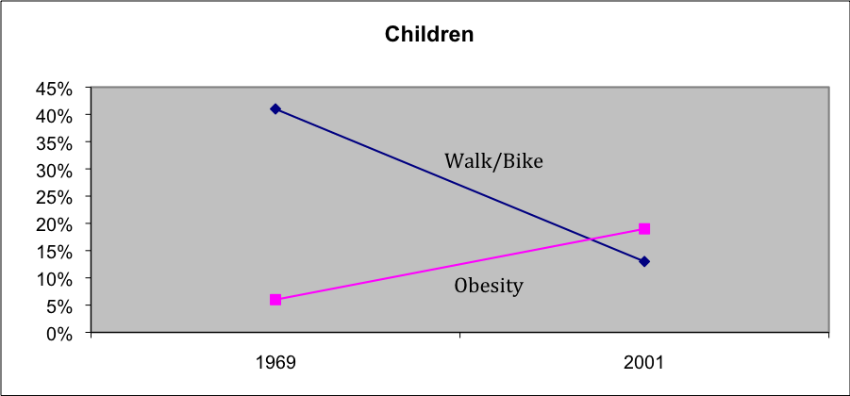
- Cycling contributes to personal health by enhancing fitness and providing an enjoyable, convenient and affordable means of exercise and recreation. The most effective fitness routines are moderate in intensity, individualized and incorporated into our daily activities. Cycling and walking can accomplish this while also providing mobility.
- Cycling can eliminate road rage and increase civility among community members. The freedom from entrapment in a vehicle, higher intimacy with the natural environment and other travelers and the feeling of satisfaction of getting around on one’s own power improves the cyclist’s general attitude.
- Almost 50% of adults in the U.S. do not get the recommended amount of physical activity. Among all states, West Virginia has the greatest percentage (almost 65%) of adults who do not achieve this level. Additionally, over 80% of U.S. teenagers do not get adequate aerobic physical activity. The estimated annual economic cost (in year 2003 dollars) to the United States of physical inactivity in adults exceeds $251 billion.
- Cycling provides access and transportation to segments of the population who would not otherwise be able to travel independently including those who:
  - Cannot or choose not to own a motor vehicle;
  - Do not have access to a motor vehicle when needed;
  - Cannot or choose not to use public transportation.
- A forthcoming review article demonstrates significantly higher levels of health and fitness were associated with bike commuting. (Scandinavian Journal of Health Promotion, 2011)

Improved Physical Environment
- Bicycling reduces air pollution, reduces the exhaust dirt that sullies our houses, buildings and infrastructure, and frees up valuable space that could be used for other more productive and attractive applications.
- Bicycling can most easily replace 1-5 mile motor-vehicle trips that are the least fuel-efficient and generate the most pollution per mile.
- Replacing auto trips with bicycling mitigates ozone depletion, the greenhouse effect, ground-level air pollution, photochemical smog, acid rain and noise pollution.

More Prosperous Local Economy
- Bicycling accommodations increase property values, business revenue and jobs.
- Bicycle friendly communities attract educated highly paid residents and visitors that contribute to the local economy.
- Since bicycles take up less space, a significant shift in transportation from motorized to bicycling frees space for other more productive uses. Automobile parking currently occupies a major fraction of valuable land within Morgantown. As a business person, which would you prefer to own, Ruby Memorial Hospital or its parking lot that occupies approximately the same area? Confrontational statement.

Current State: Bicycling in Morgantown
Morgantown and the surrounding green rolling hills of PA and WV offer a quality of cycling comparable to world-renowned venues such as France and Italy. Morgantown, often rated as one of the best small towns in America, offers everything a cyclist could want within a 5-mile radius.

In 1993, Lance Armstrong raced on the streets of Morgantown in the prolog time trial of West Virginia’s first stage race, the KMart Classic. In town for the race, then Governor Gaston Caperton said Morgantown could be the “Boulder of the East”. Today, Boulder is one of the League of American Bicyclists’ 3 platinum-level Bicycle Friendly Communities.

Morgantown and Boulder topographies are quite different. Morgantown is a city located on multiple hills and ridges along large bends in the Monongahela River. There are very few relatively level areas to accommodate wide rights-of-way and spacious streets that can include bike lanes. Narrow street patterns in the river city were established in the 1800’s. Because of coal and limestone industries, trucks – often overweight - dominate narrow roads creating safety challenges to cyclists, especially on weekdays.

Bicycling in Morgantown is challenging. The number of trips in and through Morgantown by bike is too small to measure and probably less than 1% even in the most pleasant weather. Morgantown streets are narrow and hilly. Summers are hot and humid and winters are cold and often snowy. Roadways frequently have potholes and debris.

Motor vehicle congestion is arguably Morgantown’s biggest problem. Continuous population growth with no land use plan and no controls on development outside the city limits have led to sprawl and the attendant increased motor vehicle traffic.

Roadway “improvements” are made with no consideration for bicycles and usually make bicycling more difficult. City Council passed in 2008 a Complete Streets policy resolution that may bear on future improvement decisions. West Virginia has allocated less than ½ of 1% of transportation dollars to bicycle, walking, or mass transit. This is the lowest level in the nation. Certainly our geographic terrain is a challenge, but an investment in overall transportation efficiency is essential.

Traffic laws are frequently violated and enforcement is weak. Many bicyclists do not stop for stop signs, do not signal merges and turns, ride on sidewalks, and ride against traffic. Many motorists do not stop for stop signs, do not yield to cyclists when cyclists have the right of way, pass cyclists dangerously closely and blow their horns and shout epithets at cyclists.

Though small and practically invisible to the average resident, Morgantown’s bicycling community is vibrant. Two thriving bicycle shops: Wamsley Cycles and Pathfinder support the cycling communities. Tens if not hundreds of cyclists regularly commute to work and the University. Spring through autumn one can find road, cyclocross and mountain bike races within a few miles of downtown practically every weekend. Some local cyclists have gained national renown for their competitive achievements.

Despite or perhaps because of the challenges Morgantown cyclists face, they are a close-knit social community. A recent practically impromptu dinner raised $9,000 for one young member with brain cancer. Social rides of various distances and difficulties roll out every Saturday and Sunday throughout the year from the Courthouse located downtown. During the summer, tens of competitive cyclists do weekly high-intensity training rides from downtown. Recreational cyclists come from surrounding communities as well as Morgantown to ride Morgantown’s well-publicized rail-trails. Mountain bikers and cyclocross racers regularly come from within WV and from neighboring states to ride and race the myriad nearby less official single-track trails. Every Sunday throughout the winter, tens of mountain bikers tackle dirt single track in unofficial local cycle parks. Monbikeclub and CRC Google groups have practically daily posts of ride invitations and tips on bicycling routes and other useful information. BikeMorgantown.com is becoming the City’s bicycling education information center.

Morgantown is certainly not ready to be compared to Boulder with its bicycle lanes on relatively level, spacious municipal topography. Since 2006, however, the Morgantown City Council and its Traffic Commission have begun to take deliberate steps toward supporting important progress toward improving cycling in the city. A Bicycle Board was established that year as a resource to the Traffic Commission for the following purposes authorized by the City Council and City Manager:

- review and support the implementation of Article 373 on Bicycles of the Morgantown Municipal Code;
- work to make Morgantown a Bicycle Friendly Community (BFC) as defined by the League of American Bicyclists so as to reduce traffic demands, afford better air quality, and improve public health;
- make recommendations for improving signage, safety, capacity and facilities for bicycles on streets, trails or other land design or use which supports cycling;
- advocate for the provision of bicycle travel opportunities to and from locations such as residential, employment, commercial, education, recreation and transit centers;
- promote the development of safe bicycle routes to schools;
- encourage use and enjoyment of bicycling and bicycle safety education.

The Bicycle Board has 17 members appointed by the Traffic Commission based on recommendations from the Board itself. The chair of the Board is a cyclist who is also an engineer, project manager and management consultant who is also a League of American Bicyclists certified League Cycling Instructor. (Personal information is not appropriate.) Board membership includes a member of City Council, Traffic Commission and the Morgantown Monongalia Metropolitan Planning Organization; West Virginia University Director of Transportation and Parking; a former executive director of the area Metropolitan Planning Organization; representatives from most wards in the city and adjacent areas and ex-officio members including the Director of City-County Transit Services; the Assistant City Engineer and a member of the Board of Parks and Recreation Commissioners. The Board is organized in committees that have focused primarily on bicycle education, infrastructure, parking, mapping, and occasional events. The Board meets monthly and submits monthly progress reports to the Traffic Commission.

In 2007, the Bicycle Board with the approval of the Traffic Commission and the City Manager, developed an application for a BFC award so that it could receive feedback from the League on how to best set priorities to take steps toward earning a first level of recognition by the League’s BFC program.

Also in 2007, the Morgantown City Council passed a policy resolution to adopt “Complete Streets” as a City standard in any new street construction or major renewal. Due to this City initiative, the Greater Morgantown MPO also adopted the Complete Streets policy.

In 2007, the MPO completed its update of an area Transportation Plan. This plan includes a non-motorized section, and the MPO executive director plans to continue expanding this section of the plan in the plan update projected to be completed in 2012. The Morgantown Municipal Bicycle Board will be fully represented in this process which is scheduled to being in 2011.

In 2010, with the leadership of the Bicycle Board’s Parking Committee and approval of the Traffic Commission, the City Council approved funding to implement a plan for bicycle parking rings to be installed on downtown parking meters. These rings are identified for bicycle use and have assisted cyclists in gaining parking access to central city businesses. In 2011, The Bicycle Board will initiate the procurement and installation of bicycle lockers in parking garages with funding approved by the City Council.

Morgantown and its surroundings have 50 miles of well-constructed, completed rail trails that were completed in 2000. The use of these trails was initially mostly for recreation and fitness. Over the past decade, however, growing numbers of cyclists and pedestrians are using the rail trails for commuting to classes, employment, and events and for efficiency connections between thoroughfares and various destinations. The State of West Virginia Department of Transportation (WVDOT) has jurisdictional control of most of the major thoroughfares within the City and has been reluctant to support cycling as a practical mode of transportation. Yet with the persistent advocacy by the Bicycle Board, the Traffic Commission, City Council, WVU and the MPO, incremental changes in State receptivity and practice have been evident.

Working with the City Administration, the Bicycle Board applied for and received a two-year grant for bicycle education from the WVDOT. The matching funds were provided by the City of Morgantown, and one year of a multi-dimensional educational program has implemented. With the hilly topography of the community, bicycle education, with mapping and additional signage to follow, has a high potential of increasing the numbers of cyclists as well as improving the awareness of the legitimacy of cyclists sharing the road.

The WVDOT has also approved a request to establish a half-mile climbing land on one of the major thoroughfares which connect two sections of the City along with two campuses of the University. This lane will be located along a relatively steep slope of a highway with a 45 miles per hour speed limit within the City limits and be recognized as an important means for permitting cyclists of various skills and experience to travel by bicycle to important destinations within the City. City cyclists have provided organized advocacy for the completion of this project since 1987. It is anticipated that with pending grant funding, this project can be completed in 2011.

Bicycling is fun. Anyone who has ever ridden a bicycle has probably experienced the joy and freedom of bicycling. For many of us as children, the bicycle expanded our universe and provided us with a practical means of transportation for trips in our neighborhoods. Most of us got our motor vehicle driver license around the age of 16 and left our bicycles behind. The motor vehicle quickly became indispensible for practically all our transportation. The thrill, power and adventure of being able to go anywhere quickly was soon tempered by traffic congestion and the $7,000 annual costs to purchase, insure, operate, and maintain our automobiles. Eventually, some of us realized that even though motor vehicles usually got us around quickly, the ever growing amounts of time we were spending holding a steering wheel was robbing us of our physical fitness and more generally, our health. Realizing that many of our trips are still the same distance as when we made them as children on our bicycles and recalling how much fun it was to travel by bicycle has motivated some of us to become bicyclists again in addition to being motorists. Now, we’re trying to reshape ourselves as well as our transportation environment to regain the joy and freedom of bicycling.

For most Morgantown residents, the private motor vehicle is perceived to be the only practical transportation option. Morgantown’s hilly environment naturally makes bicycling and walking challenging. Our narrow roads, heavy traffic and ignorance of bicyclists’ rights and duties make bicycling terrifying to any but the most experienced, fit and intrepid cyclists. To get more Morgantown residents to use bicycles rather than private motor vehicles, we must make bicycling safer and more personally satisfying than driving the car, at least for some trips.

Bicyclists are a heterogeneous group, with widely varying skills, needs, and travel purposes. The City must work to accommodate all types of cyclists. This is the City’s plan to do that.

Stakeholder Analysis
A stakeholder is a person or group affected by the plan or in some way accountable for it.
In order for any plan to be successful, the stakeholders must sufficiently benefit from its implementation. Obviously, bicyclists are stakeholders in this plan but others who can be even more affected by it and who are essential to its implementation include the Mayor and City Council; the City Manager and his staff including the City Engineer, Chief of Police; Parking Authority Director; BOPARC Director; Greater Morgantown MPO Director; Monongalia County Commissioners and the Secretary of the WV Division of Transportation. The following sections identify these stakeholders’ needs.

Types of Bicyclists that Must Be Accommodated
Cyclists are a heterogeneous group with widely varying training, ability and experience. Consequently, cyclists also have widely varying perceptions of bicycling safety and risk.

Cyclists’ perception of safety and risk also depends on where they ride their bikes, why they ride their bikes and how often they ride their bikes.

Where cyclists ride bikes ranges from rail trails that are flat and have no motor vehicles to narrow, hilly, winding, roads with heavy motor vehicle traffic.

Why cyclists ride also covers a wide range. Reasons for riding a bike include,
- Recreation;
- Long distance touring;
- Fitness or competition;
- Running errands;
- Commuting to work or school.

How often cyclists ride varies from year-round every-day to only occasionally.

The City’s Bicycle Plan must recognize and accommodate these differences. Unfortunately, this means there is no one “design cyclist,” representative of all types of cyclists around which the system may be planned. The Bicycle Plan must account for the diversity of bicyclist abilities, skill levels, risk tolerances, and travel purposes observed among cyclists.

The Federal Highway Administration’s National Bicycling and Walking Study identifies three broad categories of cyclists:
- Advanced Bicyclists (Type A), are experienced adults who are comfortable riding in most traffic conditions.
- Basic Bicyclists (Type B) are novice adults or adolescent riders who are more wary of busy or high-speed streets.
- Child Bicyclists (Type C) consists of young children who require substantial or total protection from vehicular traffic.

The three groups of cyclists are described further below.

Type A: Advanced Bicyclists
This group is comfortable in most traffic situations, even arterial streets with high traffic volume. In selecting a route, Type A cyclists will choose the most direct route with minimal stop signs and delays. They will not typically utilize a lower traffic bike route or trail alternative when a more direct, undesignated route exists.

Type A cyclists are best served by adopting minimal “bicycle-friendly” design standards for all streets, and wide curb lanes along arterial streets.

Type B: Basic Bicyclists
Type B riders include adolescent cyclists and adults who ride only on occasion. This group is less comfortable operating a bicycle in the midst of heavy motor vehicle traffic and instead desires greater protection from motorized traffic than Type A. These riders may lack the skills necessary to ride in city traffic, or they perceive a safety risk in doing so.

Type B riders will often ride on sidewalks in high-traffic locations, which can actually place them at greater risk, especially at intersections. Type B cyclists benefit most from bicycle routes with low traffic volume, bike lanes on arterial streets, or completely separated bicycle trails. While directness of route is still a critical factor, Type B cyclists are willing to detour slightly to avoid motor vehicle traffic or significant grades.

Type C: Child Bicyclists
Child cyclists require substantial protection from motor vehicles, and often ride only with adult supervision. Children cyclists have the least amount of bicycling skill and they often are unaware of the danger that their unpredictable behavior presents. This unpredictability can pose safety risks for other cyclists as well, especially on trails. For children, bicycling is a form of play as well as basic transportation, and usually confined to neighborhood streets, parks, or trails.

Type C cyclists are best served through bicycle safety and skill-building education, traffic calming in neighborhoods, improved access to neighborhood destinations and schools, and recreational trails conducive to family outings.

Public Officials
Following are public official stakeholders and their needs.

Mayor/City Council
Mayor/City Council requires that,
- the Bicycle Plan satisfy in whole or in part the Bicycle Board’s procedural guidelines;
- be congruent with other city plans;
- the Bicycle Plan improve the City’s business and social climates and the City’s position as a livable community;
- that resources be identified for the Plan’s implementation.

City Manager
City Manager requires that,
- the Bicycle Plan be approved by City Council;
- resources be identified for the Plan’s implementation;
- the Bicycle Plan be congruent with other city plans;
- the Plan improve the City’s business and social climates and the City’s position as a livable community.

Director of Development Services
The Director of Development Services requires that,
- the Bicycle Plan be approved by the City Manager;
- the Bicycle Plan be congruent with other City plans.

City Engineer
The City Engineer requires that,
- the Bicycle Plan be approved by the City Manager;
- the Bicycle Plan be congruent with other City plans;
- the Bicycle Plan be congruent with prevailing engineering standards and principles.

Chief of Police
The Chief of Police requires that,
- the Bicycle Plan be approved by City Council;
- the Bicycle Plan be congruent with City and State law;
- resources be identified for the Plan’s implementation.

Parking Authority Director
The Parking Authority Director requires that,
- the Bicycle Plan be approved by the City Manager;
- the Bicycle Plan be congruent with other City parking plans.

Board of Parks and Recreation Commissioners (BOPARC) Director
The BOPARC Director requires that,
- the Bicycle Plan is approved by the City Manager;
- resources be identified for Plan implementation, especially implementations that affect City parks.

West Virginia University

Morgantown Monongalia Metropolitan Planning Organization (MPO) Director
The MPO Director requires that the Bicycle Plan be an integral part of the MPO’s Long Range Transportation Plan. That it be consistent with the LRTP’s goals and objectives and that it comply with State and Federal law and regulations.

County Commissioners
Secretary WVDOT

Projects
This section of the plan repeats the education, enforcement, engineering, encouragement and evaluation objectives and lists projects whose completion would contribute to accomplishing each objective. A responsible entity is identified at the top of each list of projects because the assigned projects are within the entity’s scope of work and power to accomplish. Ultimately, the Morgantown City Council is responsible for achieving the goal, objectives and projects.

Education

Objective:
Educate bicyclists on how to operate their bicycles as vehicles and educate motorists how to treat bicyclists as drivers of vehicles.

Cyclists fare best when they act and are treated as drivers of vehicles
WV law as in all 50 states grants every person riding a bicycle upon a roadway the same rights as drivers of vehicles and subjects cyclists to the same duties. Cyclists fare best when they act and are treated as drivers of vehicles. Bicyclists reduce the risk of getting hit by a car when they are most visible and predictable. When they operate their bicycles as vehicles, they position themselves where motorists can see them and they behave the way motorists expect other vehicles to behave. It is easy for motorists to treat bicycles as vehicles when bicyclists drive their bicycles as they would drive their vehicles. For example, when bicyclists ride straight rather than swerving and signal sideways movements or turns, motorists know what to expect and can prepare and even yield to them.

Many cyclists hug the right edge of the road. It is generally safer to ride farther out into the lane. When the lane is narrow (less than 14-feet wide) and cyclists ride too far to the right, they sometimes get forced off the road because cars pass when there’s not enough room. When cyclists learn that they have the same rights to the road as motorists and learn where to position themselves in the lane, they can lose their fear and gain more confidence which enables them to ride more predictably and thus more safely.

Even when they drive their bicycles as vehicles, unpredictable things can happen. If a pothole, debris or a sunken drain grate is in their path and they swerve to avoid it, they are more likely to get hit than if they had simply ridden in a straight line that avoided these common roadway hazards. In addition to learning the rules of the road and driving their bicycles as vehicles to prevent crashes, cyclists also need to learn special physical skills to avoid crashes. Such skills include
- avoiding obstacles without swerving;
- stopping in the shortest possible distance, for example when a car pulls out in front of you;
- turning in the shortest possible radius, for example when a car passes you and then cuts in front of you and turns right.

Some motorists also do not know that the law gives bicyclists the same rights to the road as it does to them and they do not know how they should drive around bicycles. Education as well as enforcement can help ensure that they treat bicyclists as drivers of vehicles.

Projects:
The City Council shall:
- Establish and maintain a bicycling education plan
- Conduct annual reviews of bicycling education progress
- Continue the Morgantown Effective Bicycling Education Program as defined in the 2008 Transportation Enhancement Program grant, which includes educating motorists on cyclist rights and duties and how to drive around cyclists
- Continue to support the Confident City Cycling program as defined on BikeMorgantown.com including Traffic Skills 101 and Bicycle Commuter courses
- Encourage the Board of Education to establish a Safe Routes to School (LAB Kids II) class in every school
- Coordinate with WVU to provide LAB Bicycle Commuter and Traffic Skills 101 courses to all students faculty and staff
- Request WVDMV to include in the motor vehicle driver exam a question on proper driving with bicycles
- Mention BikeMorgantown.com in any City-sponsored transportation-related education activities

Enforcement

Objective:
Enforce traffic laws whose violations endanger bicyclists and discourage bicycling

Almost every collision involves a traffic violation
Obedience to traffic laws prevents collisions. Enforcing traffic laws can increase compliance as well as educate motorists and bicyclists about traffic law.

Motorists and bicyclists share responsibility almost equally for collisions between bicycles and motor vehicles. Most collisions result from a traffic violation. In approximately half of collisions between motor vehicles and bicycles the motorist is at fault and has committed one or more traffic violations. In the other half the bicyclist is at fault and has committed one or more traffic violations.

In a Federal Highway Administration study of 3,000 collisions, the following violations account for over half:
Violation | Percent of all car-bike collisions | Fault
Ride out at stop sign | 9.7% | Bicyclist
Drive out at stop sign | 9.3% | Motorist
Ride out at intersection | 7.1% | Bicyclist
Drive out at midblock | 6.9% | Motorist
Motorist left turn – facing cyclist | 5.9% | Motorist
Ride out at residential driveway | 5.1% | Bicyclist
Motorist right turn | 4.7% | Motorist
Ride out at midblock | 4.4% | Bicyclist

Clearly, citing motorists and bicyclists for running stop signs and red lights and for failure to yield when merging could make bicycling a lot safer.

Cyclists must be given equal treatment by police and the courts in the enforcement of traffic laws and in the investigation of crashes that involve bicyclists. Cyclists must be viewed as fully equal to other parties in the determination of culpability in crashes, the economic value of injuries or death, and non-economic losses that are commonly awarded to crash victims.

Projects:
Morgantown Chief of Police shall:
- Establish and maintain a plan for traffic enforcement to improve bicycling safety and to reduce the perceived risk of bicycling in Morgantown
- Conduct an annual Enforcement for Bicycle Safety workshop with the Morgantown Police department
- Send rights and duties postcard to motorists that cyclists or others observed and reported violating bicyclist rights
- Handout rights and duties card along with citation to cyclists who violate rules of the road
- Cite bicyclists who run stop signs, ride against traffic, make improper turns or violate other laws
- Capture and publish daily, monthly and annual data on traffic violations involving bicycles, crashes involving bicyclists and the cause of crashes
- Cite motorists for improper driving around cyclists with emphasis on failure to stop for stop signs, failure to yield at intersections and passing cyclists too closely and too fast
- Require ticketed cyclists to complete Traffic Skills 101
- Support traffic judge requiring motorists that police cite for breaking the law and jeopardizing cyclists to complete the LAB course for motorists
- Every year, 2 months before the beginning of the City’s annual budget cycle, conduct a review with the City Manager, City Council, the Traffic Commission and the Bicycle Board of bicycle use, violation citations, crash statistics and recommended actions for improvement

Engineering

Objective:
Remove roadway impediments to bicycle use and build appropriate improvements to make bicycling a safer and more attractive transportation mode than motor vehicle use

A wide range of needs:
Roadways and separate facilities must conform to state and national standards and allow for safe, legal and efficient traffic movements. Construction and maintenance of roads must equitably serve all users. Separate facilities must be maintained at a level not less than that applied to the public roadway. Trip-endpoint and waypoint facilities such as parking must serve bicyclists.

Novice and experienced cyclists have many similar but also some different needs of the infrastructure.

Novice cyclists want to be segregated or separated from motor vehicle traffic to feel safe. Increasing segregated facilities such as rail trails and increasing separated facilities such as bike lanes can be expected to increase the number of novice cyclists.

Bike Paths
The Monongahela River trail and the Deckers Creek trail are unquestionably two of Morgantown’s most valuable assets.

These trails often see first time cyclists as well as returning cyclists who haven’t cycled in years discovering or rediscovering the joy and freedom of bicycling.

Increasing the number and length of Morgantown segregated bike paths, rail trails, shared use paths is desirable but may not be affordable. Particular attention must be paid to intersections between paths or rail trails and roadways. Crossings between trails and roadways can be more dangerous than crossings between roadways because trails crossings may not have good sight lines and may not have sufficient traffic control.

To reduce crossing conflicts, the following measures should be considered
- grade separated crossings;
- signalized crossings
- raised intersections;
- cyclist activated crossing controls;
- signage.

Bike lanes
Bike lanes may increase the incidence of crashes at crossings because cyclists are less visible in the bike lane than in the travel lane. Three common causes of crashes at crossings are the “right hook”, “left cross” and “drive out”.
Right hook: motorist looks left turns right into cyclist in the bike lane.
Left cross: motorist turns left into a cyclist in the bike lane who was obscured by the motor vehicles in the travel lane.
Drive out: motorist pulls out in front of the cyclist in the bike lane because the motorist’s view of the cyclist was obscured by parked cars to the right of the bike lane or trees, shrubs and other obstacles in the sight line between the motorist and the cyclist in the bike lane.

With more motorists talking on cell phones, texting, looking at their GPS and other distractions, it becomes ever more imperative that cyclist visibility not be compromised by positioning the cyclist where he or she can’t be seen.

Bike lanes can lead both motorists and cyclists to believe that bicyclists belong in the bike lanes and not on the roadway. When a bicyclist chooses to move from the bike lane into the travel lane, the belief that the bicyclist belongs in the bike lane can lead to conflicts, crashes and injury. When bike lanes are installed the following actions must be considered to preclude these conflicts:

Terminating the bike lane sufficient distance from intersection to enable the cyclist to safely merge into travel lane in advance of the intersection;

Appropriate signage warning motorists that cyclists may merge at probable merge points, signage informing motorists that cyclists may use the travel lane, enforcement including citing motorists that do not yield to cyclists where appropriate and education campaigns including billboards, TV spots, radio PSAs and newspaper articles to educate motorists and bicyclists that it is lawful and indeed safer sometimes to merge from the bike lane or bike trail onto the roadway.

Bike lanes are appropriate
- on arterials where the speed difference between motor vehicles and bicycles is high (>20 mph) and
- there are no or few collectors and
- collector traffic volume is low.

Roadways
Some rail trail cyclists eventually look for ways to ride their bikes to the trails and then even to ride their bicycles on the streets and roadways for both recreation and practical transportation.

Both novice and experienced cyclists prefer to use rail trails and bike lanes but they also recognize that such facilities may not be as safe or efficient as roadways. Rail trails often take more circuitous routes and have higher rolling resistance surfaces that can negate the advantage of not having to climb a hill.

Most experienced cyclists also do not enjoy riding in motor vehicle traffic but recognize that they must do so to quickly get where they need to go in Morgantown. All cyclists need roadways that are free of surface hazards and that do not obscure view of the cyclists.

Some surface hazards can be fatal to a cyclist but would not faze a motor vehicle. Such hazards include in-line drainage grates, longitudinal cracks, debris and slippery surfaces such as metal plates or snow and ice. Maintaining the roadway surface safe for bicyclists as well as for motorists must be a first priority.

Roadways must enable the bicyclist to always be visible to other vehicles and should enable motorists to safely pass slower moving cyclists. Hill crests, blind curves and narrow uphill lanes are particularly problematic. When a cyclist has gone over the crest of a hill or are into a blind curve in a narrow lane, faster moving overtaking vehicles may not have sufficient time to react appropriately. Controlling motorist speed, making motorists aware of cyclists’ presence and enabling motorists to pass cyclists while leaving sufficient space between the motor vehicle and bicycle can make Morgantown roadways safer and more attractive for cyclists.

Controlling motorist speed can be accomplished with speed limit signs and speed humps. These devices must be selectively placed where they will not unduly impede traffic and in the case of speed limit signs where they will not be regularly ignored. An unwarranted speed limit sign will be ignored and teach motorists to ignore all speed limit signs.

Making motorists aware of cyclist presence can be achieved by signage such as Share the Road signs, Shared Lane Markings and Bicycles May Use Full Lane signs (R4-11). Since cyclists usually ride as far to the right side of the roadway as practicable, maintaining crossings free of visual obstructions such as trees and shrubs, parked cars and other obstacles is also necessary.

Enabling motorists to safely pass bicycles can be achieved by widening the right lane to 14-feet, especially on uphill sections.

Of course, law enforcement is required for most of these engineering measures to be effective.

Projects:
The City Manager shall:
- Establish and maintain a plan for improving Morgantown’s infrastructure for bicycling.
- Implement the Complete Streets policy established in 2008: all street resurfacing or other modifications will include a written Complete Street plan that is reviewed and commented on by the Bicycle Board before they can be implemented.
- Use the AASHTO Guide for the Development of Bicycle Facilities for the design of every new street and for every street improvement.
- Install Shared Lane Markings and Bicycles May Use Full Lane signs on all City maintained arterials.
- Install Share the Road signs on all City maintained arterials that speed limits greater than 35 mph.
- Arrange for the state to install Shared Lane Markings and Bicycles May Use Full Lane signs on all state maintained arterials that have speed limits less than 35 mph.
- Arrange for the state to install Share the Road signs on all State maintained arterials that have speed limits greater than 35 mph.
- Advocate secure short term bicycle parking within 100 feet of every bicyclist destination at commercial districts.
- Encourage weatherproof and vandal-proof long term bicycle parking in every city owned or managed parking garage.
- Coordinate with Mountain Line and WVU to establish reasonable bicycle parking at all bus and PRT stops.
- Replace all drain grates that can catch bicycle wheels with grates that are bicycle friendly.
- Keep roadways, especially bike lanes and uphill shoulders, clear of glass, debris, snow and ice.
- Encourage redesigning University Avenue between Falling Run Road and Patteson Drive, to widen the up-hill side, providing a bicycle-climbing lane.
- Conduct a comprehensive traffic flow and redesign study of the Sunnyside, Wiles Hill and Evansdale areas to minimize the difficulty and perceived risk of bicycle travel between WVU campuses.
- Install bicycle-climbing lane on Monongahela Boulevard between Eighth Street and Evansdale Drive.
- Install bicycle-climbing lane on Monongahela Boulevard between Boyers Avenue and Patteson Drive.
- Install a bicycle lane on both sides of WV 705 from Willowdale Road to Mileground Road.
- Encourage the state to make Greenbag Road bicycle friendly.
- Improve alignment and sight lines at Deckers Creek trail crossings of Deckers Creek Blvd. and consider enhanced traffic control measures.
- Maintain the rail trails to be free of glass, snow and ice.
- Install bike/ped bridge across Decker’s Creek from Valley Crossing to Brockway Avenue.
- Install bike/ped bridge in the location of the former Decker Avenue bridge across Decker’s Creek.
- Build the Campus Connector from Grant Avenue to the WVU Evansdale Campus (with steps and bike-rail).
- Design and build Health Center Connector from old North Fire Station to Law School, the Health Center, and Mountaineer Field.
- Finish Krepps Park to Star City connector.
- Encourage WVDOH to coordinate with Star City to widen University Avenue from Boyers Avenue to Patteson Drive during course of regular maintenance (resurfacing) sufficiently to enable motorists to pass bicyclists safely, especially on the climbing sections, or design and develop a Star City bicycle path parallel to University Avenue from Boyers Avenue to Patteson Drive.
- Design and build connector from Falling Run Road through WVU Farms to West Run Road to the Mon River Trail (at Beechurst Avenue and near Van Voorhis Road); and Mon River Trail to Bakers Ridge Road and University High School.
- Move the intersection of West Run Road and Route 119 to the Easton Hill Road. Widen and straighten West Run Road to improve sight lines. Install shared lane markings and Bicycles May Use Full Lane signs from Van Voorhis Road to the intersection with Easton Hill Road. Install Share the Road signs from the Route 119 and Route 857 intersection south on Route 857 to Old Cheat Road, along the Old Cheat Road, on Cheat Road from Cheat Lake to Pierpont Road.
- Develop bike path in the West Run valley from Van Voorhis Road to I-68 and then west of I-68 in the general direction of I-68 to Sabraton to connect with the Decker Creek trail.
- Every year, 2 months before the beginning of the City’s annual budget cycle, conduct a review of bicycle infrastructure issues and improvements with City Council, the Traffic Commission and the Bicycle Board.

Encouragement

Objective:
Provide amenities, rewards and support to citizens for riding their bicycles rather than driving their cars. Encouragement moves people from contemplating riding their bicycles for transportation to actually doing it.

Projects:
The City Manager shall:
- Establish and maintain a budget to enable implementation of this plan.
- Coordinate with the Morgantown Monongalia MPO and the Monongalia County Commission to establish and maintain a Monongalia countywide bicycle plan
- Lead statewide bicycle plan development.
- Pay bicycle instructors a reasonable wage for the work they do.
- Encourage management of key City offices such as Engineering, Public Works and Police departments to improve support of bicycling in Morgantown.
- Establish a bicycle route map for the City and classify all streets in terms of their bicycle friendliness.
- Establish way-finding signage and roadway markings to support the bicycle route map.
- Coordinate with the Morgantown Monongalia MPO and WVU and other employers to provide bicycle parking, lockers and shower facilities for employees who chose to bicycle to work.
- Establish a BikeMorgantown orientation package for newcomers.
- In conjunction with local businesses and the local bicycling community, support regularly scheduled rides.
- Establish and mark safe routes to schools extending at least ¼ mile from every school including Eastwood Elementary School, Mountaineer Middle School, Dorsey Avenue Pre-school, Mountainview Elementary School, North Elementary School, Suncrest Elementary and Middle Schools, Morgantown High School, and South Middle School.
- Provide training to parents and students on safe routes and commuting to school.
- Remove school prohibitions on bicycling to schools that have established safe routes.
- Reward students for bicycling to school.
- Reward people for riding their bicycles instead of driving cars.
- Review current implementation and consider expansion of the City ordinance requiring developers of multiple family dwellings to provide bicycle parking and storage.
- Promote with great exuberance Bike to Work month, week and day by riding his bike down Main Street.
- Achieve LAB Bicycle Friendly Community Bronze level award by 2012, Silver by 2015 and Gold by 2020.

Evaluation

Objective:
Measure bicycle use and bicycling incidents and use the data to identify improvements in behaviors and infrastructure.

Projects:
The City Manager shall:
- Establish and maintain a plan for measuring and analyzing the effectiveness of the City’s Bicycle Plan.
- Measure resources applied to implement this plan and publish the results monthly and annually.
- Measure bicycle use and publish the results monthly and annually
- Measure bicycle crashes and bicycle injuries and publish the results monthly and annually.
- Analyze bicycle use and crash data to identify opportunities for increasing use and reducing crashes.
- Conduct an annual review with City Council, Chief of Police, City Engineer and the Bicycle Board of trends in bicycle use and incidents and identify required changes to the Bicycle Plan and related plans.

Equity

Objective:
Treat bicyclists as equals to motorists in all city activities.

Bicyclists are people, too
Cyclists have the same right to fair and equitable treatment by the government as other road users. Cyclists have a right to equal legal status and equal treatment in traffic law. Morgantown traffic laws and regulations must be fair, equitable and “vehicle-neutral” to the greatest extent possible. Cyclists’ access to all destinations must be protected. Laws that discriminate against cyclists, or restrict their right to travel, or reduce their relative safety, must be repealed.

Projects:
The City Council shall:
- Repeal ordinances that discriminate against bicyclists, or restrict their right to travel, or reduce their safety relative to other travelers
- Conduct an annual review of incident statistics to identify trends and to identify enforcement improvements

Resources
Following are resource estimates for each initiative:

Funding Strategies
Grants
Federal
State
Private
City budget
Activities

References
- Bicycle Board Procedural Guidelines, http://bikemorgantown.com/Docs/Bicycle_Board_ProcGuide.doc
- February 2007 Bicycle Board Recommendations to Traffic Commission, http://bikemorgantown.com/Reports/20070207_recom_to_TC.doc
- Morgantown’s September 10, 2007 Application for LAB Bicycle Friendly Community Award, http://www.morgantown.com/bike-board-documents/BFC%20Application.zip
- LAB response to Morgantown’s 2007 Bicycle Friendly Community application, Morgantown, WV BFC Feedback Spring 2008.pdf
- Morgantown’s Complete Streets resolution.
- Greater Morgantown MPO Complete Streets policy.
- Various Shared Lane Marking reports and correspondence (Bicycle Board’s October 1, 20087 Recommendations to Traffic Commission: Roadway Symbol Plan_20071001.doc, SLM_location_plan_20080513_v04.xls )
- Morgantown’s 2010 Confident City Cycling Accomplishments, October 2010 (Morgantown CCC AccomplishmentsFY2010_v04.docx)

Cycling at a rate of 11 mph expends approximately 6 kcal/kg-body-weight/hr ª. A 180 lb (81.8 kg) adult cycling at 11 mph for 1 hour would expend 6 kcal/kg/hr * 81.8 kg = 491 kcal. Therefore, 491 kcal/11 miles = 44.6 kcal/mile. One gallon of gasoline contains approximately 31,000 kcal. So, cyclist’s gasoline-equivalent mileage is 31,000 kcal / 44.6 kcal/mile = 695 miles. ª http://prevention.sph.sc.edu/tools/compendium.htm
U.S. National Bicycle and Walking Study, 1994
The Dominion Post, Sep. 7, 2009 p.1-A
Based on maximum of $50,000/mile estimated cost from Bikesafe: Bicycle Countermeasure Selection System, Federal Highway Administration, FHWA-SA-05-006, May 2006, p. 27.
Prevalence of Obesity Among Children and Adolescents: United States, Trends 1963-1965 Through 2007-2008 by Cynthia Ogden, Ph.D., and Margaret Carroll, M.S.P.H., Division of Health and Nutrition Examination Surveys http://www.cdc.gov/nchs/data/hestat/obesity_child_07_08/obesity_child_07_08.htm#figure1
Robert Wood Johnson foundation (2008; http://www.rwjf.org/files/research/researchhighlight35.4.pdf ) reports the following re: the decrease (graphics are included at the above site that breakdown by school grade level): “In 2001, only 13 percent of students walked or biked to school.5 The most recent data on active transportation among school-age children represent a significant decrease since 1969. The number of students walking and biking to school has decreased more than three-fold over the past few decades, from 41 percent of students in 1969, to only 13 percent of students in 2001.”
http://apps.nccd.cdc.gov/brfss/list.asp?cat=PA&yr=2009&qkey=4418&state=All (NOTE: Most current data is for year 2009; “recommended” level of physical activity as set forth in Healthy People 2010, http://www.healthypeople.gov/2010/Data/midcourse/html/default.htm )
http://www.healthypeople.gov/2020/topicsobjectives2020/overview.aspx?topicid=33
Chenoweth, D., and Leutzinger, J. (2006). The economic cost of physical inactivity and excess weight in American adults. Journal of Physical Activity and Health, 3(2), 148-163
11% higher home value near bike facilities – Indianapolis - $133 Billion/year revenue; 1.1 Million jobs – U. S. - $ 1 Billion/year revenue; 1,231 jobs – Colorado - $556 Million/ year revenue; 3,418 jobs –Wisconsin - $60 Million/year revenue; 1,440 jobs on $6.7 Million investment – Outer Banks - $181 Million/year revenue; 2,800 jobs from La Route Verte bike route; bike tourists spend 26% more than other tourists – Quebec Source: Flusche, Darren, The Economic Benefits of Bicycle Infrastructure Investments, League of American Bicyclists, June 2009, http://www.bikeleague.org/resources/reports/report_economics.php
On-street and parking garages.
National Bicycling and Walking Study, FHWA, Vol. 23, p. 9.
Carol Tan, Crash-Type Manual for Bicyclists, http://safety.fhwa.dot.gov/PED_BIKE/docs/ctanbike.pdf W.H. Hunter, W.E. Pein, and J.C. Stutts, Bicycle Crash Type: A 1990’s Informational Guide, Publication No. FHWA-RD-96-104, Federal Highway Administration, Washington, D.C., 1997.
Patterned after the League of American Bicyclists Equity statement: http://www.bikeleague.org/images/equity_statement_1-05-09.pdf

