FERC-CHEAT LAKE-19DecY2K23
DOMINION POST 19 DECEMBER 2023
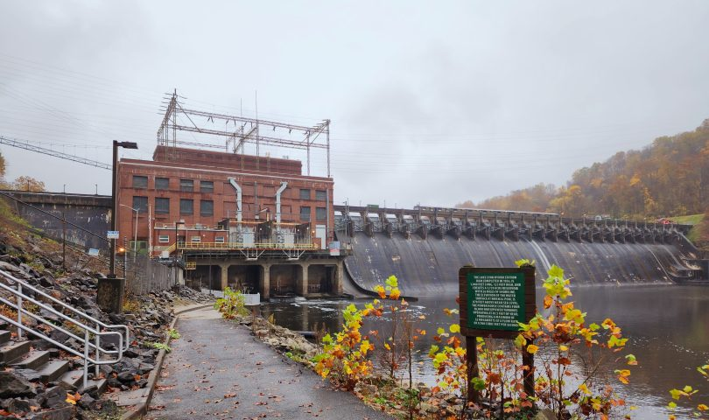Lake Lynn dam and power station. The Dominion Post file photo
COMMUNITY, ENERGY, ENVIRONMENT
Mon County officials invite FERC to Cheat Lake for boat ride, second public hearing on Lake Lynn Dam re-licensing
December 18, 2023 3:45 pm by David Beard, The Dominion Post
MORGANTOWN — The Monongalia County Commission and Planning Commission have jointly invited the Federal Energy Regulatory Commission back to Cheat Lake for another public hearing on the Lake Lynn Dam re-licensing.
The offer even includes a boat ride.
FERC is reviewing Lake Lynn Generation’s application to renew its Lake Lynn Hydroelectric Project license. As part of the application, Lake Lynn Generation/Eagle Creek Renewable Energy propose to remove 307.1 acres surrounding Cheat Lake from federal protection. FERC held a public hearing in Morgantown on the case on Sept. 25.
They say they will make no changes to operations or facilities. Lake Lynn proposes to adjust the project boundary to include only lands necessary for operation and maintenance of the power station. They will not sell any land. The eight non-contiguous areas in the boundary proposal will allow them to adjust the project boundary to follow the contour line of the high reservoir elevation, 870 feet, and bring all parts of the boundary into the highest contour line.
But the proposal has generated significant skepticism and opposition from the public and various groups with an interest in the lake — who fear the land may in fact be sold off to developers. The letters of concern also include criticism of the company’s maintenance of the public access areas.
One of the concerned groups is Cheat Lake Environment and Recreation Association. CLEAR President Duane Nichols co-signed the invitation letter with Mon Planning Commission Director Andrew Gast-Bray.
The letter is dated Dec. 7 but was filed last Friday; FERC sent out notification of its addition to the case docket on Monday.
The letter says the county commission and planning commission are extending the invitation to allow FERC to field additional public feedback following proposed changes and additional information submitted following the Sept. 25 hearing.
“Please be advised that the county would like to also invite you to visit the site and areas impacted by this process, possibly including, but not limited to a visit by boat — such was offered by County Commissioners Arnett and Sikora,” the letter says.
CLEAR sent its own letter requesting another public hearing on Nov. 28. Nichols signed the letter sent on behalf of CLEAR and “all the other residents of the region plus the various organizations having an interest in the Lake Lynn Dam, the Cheat Lake Park & Trail, the border lands, the scenic landscape and the habitat for wildlife in all its forms.”
The reason for the request, CLEAR said, was that because of the large turnout Sept. 25, not everyone was heard and not all topics were explored sufficiently. “And there may have been misunderstandings in the public domain that resulted in misguided focus on the part of the public.”
CLEAR would like the hearing to be held in County Commission chambers and include the state Division of Natural Resources.
CLEAR’s letter includes a memo sent to the county commission about the proposed hearing. It notes that preliminary discussions have already taken place among Allan Creamer at FERC, Jocelyn Phares of DNR, and Gast-Bray.
“This approach can facilitate a public process that otherwise would require much more time, more people and significantly more expense. And, this opportunity can provide a convenient public service with emphasis on intergovernmental cooperation,” it says.
The memo says CLEAR anticipates that FERC will issue a second scoping document in early December, which would need to define such a public hearing. A 30-day legal notice would then be placed in The Dominion Post to describe the hearing set in January, for example. (FERC scoping documents are used to complete the environmental assessment required by the National Environmental Policy Act.
CLEAR also is among those describing poor park maintenance. It previously told FERC, “The current re-licensing should not go forward until the language is strong enough to hold the licensee responsible for maintaining the project lands to the specifications needed to keep the operation safe and project area recreation friendly. The current owner needs to stop the dereliction of duty.”
EMAIL: dbeard@dominionpost.com
URL: https://www.dominionpost.com/2023/12/18/mon-county-officials-invite-ferc-to-cheat-lake-for-boat-ride-2nd-public-hearing-on-lake-lynn-dam-relicensing/

