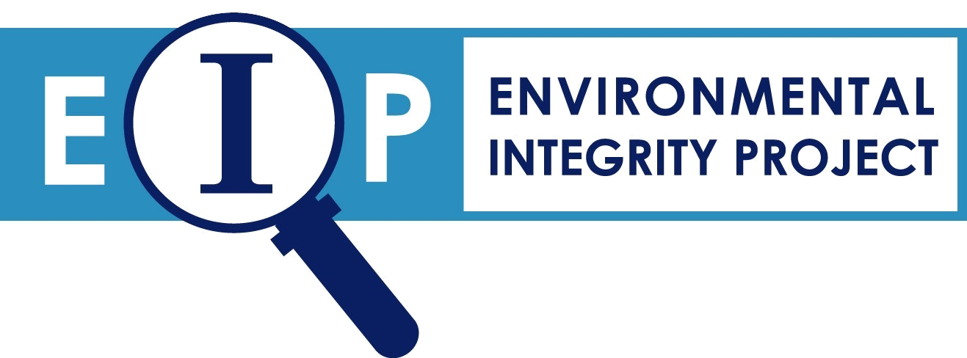

Coal Ash: SEVEN MYTHS the Utility Industry Wants You to Believe
and SEVEN FACTS You Need to Know
Myth #1: Coal ash is like dirt.
Fact: Coal ash is hazardous. According to the U.S. Environmental Protection Agency (EPA), a waste is “hazardous” if it leaches toxic chemicals, like arsenic or selenium, above a certain threshold when tested using the Toxicity Characteristic Leaching Procedure (TCLP). Using the TCLP, coal ash rarely exceeds this threshold. However, the EPA’s Science Advisory Board and the National Academy of Sciences have determined that the TCLP does not accurately predict the toxicity of coal ash. When EPA tests coal ash using a new, more accurate leach test, the resulting leachate can exceed by many times these hazardous waste thresholds. For example, when tested with EPA’s new, more accurate test, coal ash leached arsenic at up to 18,000 parts per billion (ppb), which is 1,800 times the federal drinking water standard and over 3 times the hazardous waste threshold. The new test revealed selenium leached from one coal ash at up to 29,000 ppb, which is 580 times the drinking water standard and 29 times the hazardous waste threshold. This is not backyard soil-- unless you live at a Superfund site.

Because of the pollutants in coal ash, leachate from ponds, landfills and fill projects can severely damage health and the environment. EPA’s 2010 risk assessment found the cancer risk from drinking water contaminated with arsenic from coal ash disposed in unlined ponds is as high as 1 in 50 adults, which is 2,000 times EPA’s regulatory goal for acceptable cancer risk. Dry landfills can also pose dangers to drinking water and aquatic life, according to the EPA.

Myth #2: Coal ash pollution is only a problem at old sites, and damage is largely limited to the area immediately around the disposal site.
Fact: Both new and old coal ash dumps are contaminating off-site water sources.
Monitoring data document the real world hazard that coal ash poses to our drinking water and streams. A recent report found arsenic, lead, selenium, cadmium, thallium antimony, mercury, boron, sulfate and other toxins exceeding drinking water standards in groundwater at 26 sites. The exceedances were great—at three sites arsenic was over 90 times the drinking water standard. Twenty-five of the sites were active disposal facilities. Monitoring at the large majority shows contamination is an ongoing problem, not the result of past practices that are no longer employed.

Coal ash contamination often moves offsite and poisons drinking water. At one dumpsite, arsenic was 31 times the drinking water standard in offsite groundwater. Mercury from an ash “recycling” site was found in two residential wells at over 5 times the standard. In fact, contaminated water has been known to move more than a mile from coal ash dump sites. EPA has documented 71 additional coal ash damage sites, 23 of which are known to have caused offsite contamination. EPA concedes that a lack of monitoring at most ash sites means additional damage is likely and, as yet, undiscovered.

Myth #3: Over 40 percent of coal ash is currently safely recycled.
Fact: Some coal ash “recycling” is dangerous to human health and the environment.
The claim that over 40 percent of coal ash is recycled is misleading and overlooks contamination caused by reckless “recycling” practices. Much of the touted “beneficial use” of ash is simply filling mines, quarries and other low areas to avoid disposal costs. In fact, the National Academy of Sciences has called for national regulations to prevent the contamination of water supplies from filling mines with ash. When monitoring occurs at these fills, contamination of potable groundwater is frequently found. Recycling applications such as soil amendments for agriculture or use in road construction also present concerns. Examples of recycling gone wrong include the fill and road projects in Pines, Indiana where ash contaminated drinking water with lead, arsenic, molybdenum, boron and other metals. This “beneficial use” caused the town to become a Superfund site.

Myth #4: Regulating disposal of coal ash will “kill” the ash recycling industry.
Fact: Increased waste disposal costs will give companies an incentive to find alternative uses for ash and will encourage innovation. Without disposal standards, utilities have little economic incentive to find reuses for their coal ash. To encourage recycling, EPA can regulate coal ash as hazardous when disposed, but not when recycled. EPA has done this for electric arc furnace dust, solvents, scrap metal, hazardous wastes used in zinc fertilizer, military munitions used in fertilizer, e-waste and other hazardous wastes. EPA has also developed regulations under subtitle C of RCRA for used oil and universal wastes to promote recycling while protecting the environment. These hazardous waste regulations have promoted healthy markets for the recycling of these materials.

Myth #5: A hazardous designation will fill hazardous waste landfills overnight and be prohibitively expensive.
Fact: Coal ash will never be disposed in the nation’s existing hazardous waste landfills.
EPA has the statutory authority to tailor coal ash disposal regulations. Most coal ash is handled in disposal sites owned by the utilities that can be upgraded to meet tailored requirements. Rather than shipping their ash to landfills designed for the most acutely hazardous waste, utilities will simply have to employ basic construction and monitoring safeguards and address any contamination the disposal is causing—just like federal regulations require for the disposal of household garbage.

Myth #6: The states are doing a good job regulating coal ash.
Fact: State regulations are a patchwork of largely inadequate regulation.
The majority of states fail to require basic safeguards—composite liners, leachate collection systems, adequate groundwater monitoring and corrective action—at most coal ash landfills and ponds in the U.S. A 2005 EPA report found that the great majority of coal ash produced in the top 25 coal-consuming states is allowed to be disposed into ground water tables, the most dangerous type of disposal. This widespread practice poisons water supplies and places our drinking water at great risk. A 2006 Report by the EPA and Department of Energy concluded further that approximately 30 percent of the net disposable coal ash is potentially totally exempt from solid waste permitting requirements. Major coal ash-producing states such as Texas, Ohio and Alabama have completely exempted most if not all of their coal ash from regulation.

Myth #7: The utility industry is too powerful to allow the designation of its waste as hazardous.
Fact: EPA’s original regulatory proposal designated coal ash as hazardous.
In October 2009, EPA submitted a draft coal ash rule to OMB for review, proposing that coal ash be regulated as a hazardous waste. After six months at OMB and after over 30 meetings with industry, the proposal eventually published in the federal register on May 4, 2010 was changed to include a solid waste regulatory option. Yet the justification for hazardous waste listing remains strongly embedded in EPA’s proposal. An outpouring of widespread public support for a strong, federally enforceable rule that protects all communities and their environment would make this rule a reality.

For more information: Jeff Stant, Director, Coal Combustion Waste Initiative, Environmental Integrity Project, 317-359-1306, jeffreystant@sbcglobal.net and Lisa Evans, Senior Administrative Counsel, Earthjustice, 781-631-4119, levans@earthjustice.org

National Research Council, Managing Coal Combustion Residues in Mines, 2006, pages 150-152. Also see U.S. EPA Science Advisory Board, Waste Leachability: The Need for Review of Current Agency Procedures, EPA-SAB-EEC-COM-99-002, Washington, DC, 1999, and Leachability Phenomena: Recommendations and Rationale for Analysis of Contaminant Release by the Environmental Engineering Committee, EPA-SAB-EEC-92-003, Washington, DC, 1991.
U.S. EPA, Characterization of Coal Combustion Residues from Electric Utilities – Leaching and Characterization Data. EPA-600/R-09/151, Dec. 2009, http://www.epa.gov/nrmrl/pubs/600r09151/600r09151.html, pages xii, xiv, 133, 135, 138 and 143.
U.S. EPA, Characterization of Coal Combustion Residues from Electric Utilities – Leaching and Characterization Data. EPA-600/R-09/151, Dec, 2009, http://www.epa.gov/nrmrl/pubs/600r09151/600r09151.html, page xiv, Table ES-2.
Id.
U.S. EPA, Human and Ecological Risk Assessment of Coal Combustion Wastes, RIN 2050-AE81 April 2010, page 4-7.
Environmental Integrity Project & Earthjustice, Out of Control: Mounting Damages From Coal Ash Sites, March, 2010, Executive Summary, pages v-vi, Summary of Damage Cases, pages ix-xxii, and Table 1, pages xxiii-xxix.
Id. at pages 9, 31, & 35.
U.S. EPA, Coal Combustion Waste Damage Case Assessments, July 2007. See also 75 Fed. Reg. 816, 869 n 78&80 (Jan. 6, 2010).
U.S. EPA, Final Regulatory Determination on Wastes from the Combustion of Fossil Fuels, 65 Fed. Reg. 32216, (May 22, 2000).
U.S. EPA, Characterization of Coal Combustion Residues from Electric Utilities – Leaching and Characterization Data. EPA-600/R-09/151, Dec. 2009, http://www.epa.gov/nrmrl/pubs/600r09151/600r09151.html, pages 16 and 17 citing data from American Coal Ash Association on 2006 recycling applications that indicate 24 percent of such recycling consisted of using CCW in minefills, quarries and other structural fills.
National Research Council, Managing Coal Combustion Residues in Mines, 2006, pages 11-12.
For example, the Rocky Acres fill in Illinois has contaminated groundwater with lead, arsenic, barium and chromium exceeding drinking water standards. The Swift Creek structural fill has contaminated groundwater in North Carolina with lead six times the drinking water standard and arsenic seven times the standard. See Out of Control: Mounting Damages From Coal Ash Sites, pages 16-18 and 46-49.
U.S. EPA, Characterization of Coal Combustion Residues from Electric Utilities – Leaching and Characterization Data. EPA-600/R-09/151, Dec. 2009, http://www.epa.gov/nrmrl/pubs/600r09151/600r09151.html, pages 14-17.
EPA ID # INN000508071, see http://www.epa.gov/region5/sites/pines/.
Id.
See 40 C.F.R. §261.4.
Section 3004(x) of RCRA
DPRA Incorporated, Estimation of Costs for Regulating Fossil Fuel Combustion Ash Management at Large Electric Utilities under Part 258, prepared for U.S. EPA, Office of Solid Waste, November 30, 2005, page 39.
U.S. Dept. of Energy and U.S. EPA , Coal Combustion Waste Management at Landfills and Surface Impoundments, 1994-2004, Aug. 2006, pages 45-46.

