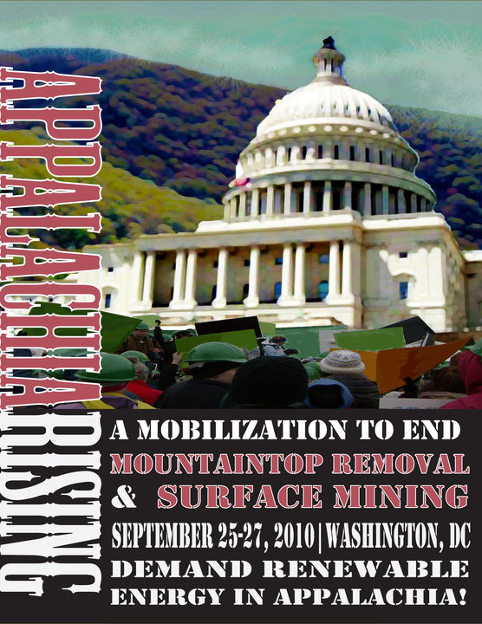
Get on the Bus! Free Bus to Appalachia Rising!
Leaves Charleston and Morgantown on Sunday Sept. 26, returns after all the Exciting Events Monday Sept. 27. For info or to save a seat email: jim_scon@yahoo.com.
Sponsored by WV Sierra Club - open to all, membership not required.

