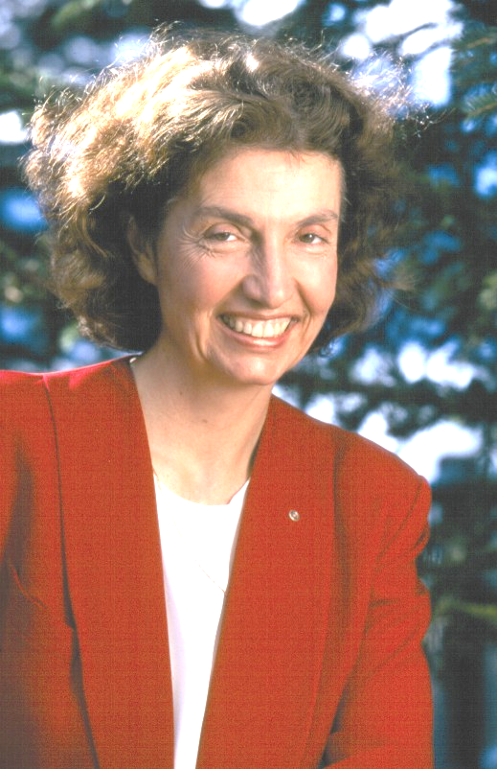

CLIMATE CHANGE SOLUTIONS
Alaska to West Virginia
Dr. Deborah Williams
President of Alaska Conservation Solutions
Deborah Williams is Alaska's foremost spokesperson on global warming. We are honored to present this free presentation

University of Charleston
GEARY STUDENT UNION - BALLROOM
Open to the General Public, Students and Faculty

THURSDAY APRIL 10, 2008
1:00 p.m.
Dr. Williams will address the alarming consequences already evident in Alaska and the commonalities between our state and hers—where impacts on wildlife, water quality, recreation, and tourism have enormous consequences. She offers practical carbon-reducing strategies that not only reduce emissions but also protect human health, save money and increase America's energy independence. Dr. Williams will educate and inspire, with ample time for interactive dialogue.

Funded by the William and Flora Hewlett Foundation

